Practical-3
Problem Definition:
Perform a comparative study of various network centrality measures on large-scale random and scale-free networks.
- Compute PageRank, Katz, Eigenvector, Closeness, and Betweenness centrality values.
- Utilize NetworkX, SNAP, and igraph libraries for implementation.
- Evaluate computational efficiency and scalability of each metric.
- Present findings using comparative tables and graphical plots.

MANDATORY SUBMISSION REQUIREMENTS
Student ID Verification:
- In Code: Declare your Student ID (Enrollment Number) and Full Name as variables and header comments at the very top of your Python script (e.g., STUDENT_ID = "23CS001").
- In Console Output: Print your Student ID and Name at the start of execution so it appears at the top of all terminal output (print(f"Student ID: {STUDENT_ID}")).
- In Plot Titles: Display your Student ID in the main title of all generated network plots, charts, and visualizations (e.g., plt.title(f"Network Graph - {STUDENT_ID}")).
Screenshots Required: You must include clear screenshots showing:
- Terminal/Console Output displaying your printed Student ID and execution results.
- Visualization Graphs & Plots showing your Student ID rendered directly in the graph title.
Note: Submissions without the Student ID clearly visible in the source code, execution logs, and graph titles will not be evaluated.
___________________________________________________________________________
Tools required:
Languages & Libraries: Python, NetworkX, SNAP (Snap.py), igraph, Matplotlib / Seaborn

Source Code
(Paste Python Code Here (Synthetic Graph Generation & Centrality Calculations))
# ==========================================
# STUDENT_ID = "23CE115"
# STUDENT_NAME = "Priya Pedhadiya"
# ==========================================
import time
import numpy as np
import pandas as pd
import networkx as nx
import igraph as ig
import matplotlib.pyplot as plt
import seaborn as sns
# --- 1. Student Identity (Mandatory Console Output) ---
STUDENT_ID = "23CE115"
STUDENT_NAME = "Priya Pedhadiya"
print("="*50)
print(f"Student ID: {STUDENT_ID}")
print(f"Student Name: {STUDENT_NAME}")
print("="*50)
# --- 2. Initialization ---
print("="*50)
print("Initializing Practical-3 Centrality Measures Study...")
print("="*50)
np.random.seed(42)
sns.set_theme(style="whitegrid")
plt.rcParams["figure.figsize"] = (12, 6)
# --- 3. Generate Random and Scale-Free Networks ---
def generate_networks(n=500, p=0.02, m=5):
print(f"Generating networks with {n} nodes...")
# Random Network (Erdos-Renyi)
g_random_nx = nx.erdos_renyi_graph(n, p, seed=42)
# Scale-Free Network (Barabasi-Albert)
g_scalefree_nx = nx.barabasi_albert_graph(n, m, seed=42)
return g_random_nx, g_scalefree_nx
g_rand, g_sf = generate_networks(n=500)
# --- 4. Calculate Centrality Measures ---
def run_centrality_benchmark(G, network_name="Network"):
results = {}
print(f"\nCalculating Centrality measures for {network_name}...")
# PageRank
t0 = time.time()
pr = nx.pagerank(G, alpha=0.85)
t_pr = time.time() - t0
results['PageRank'] = {'avg_score': np.mean(list(pr.values())), 'time': t_pr}
print(f"PageRank computed in {t_pr:.4f}s")
# Katz Centrality
t0 = time.time()
try:
katz = nx.katz_centrality_numpy(G, alpha=0.01)
except Exception:
katz = nx.katz_centrality(G, alpha=0.01, max_iter=1000)
t_katz = time.time() - t0
results['Katz'] = {'avg_score': np.mean(list(katz.values())), 'time': t_katz}
print(f"Katz computed in {t_katz:.4f}s")
# Eigenvector Centrality
t0 = time.time()
try:
eig = nx.eigenvector_centrality(G, max_iter=1000)
except Exception:
eig = nx.eigenvector_centrality_numpy(G)
t_eig = time.time() - t0
results['Eigenvector'] = {'avg_score': np.mean(list(eig.values())), 'time': t_eig}
print(f"Eigenvector computed in {t_eig:.4f}s")
# Closeness Centrality
t0 = time.time()
close = nx.closeness_centrality(G)
t_close = time.time() - t0
results['Closeness'] = {'avg_score': np.mean(list(close.values())), 'time': t_close}
print(f"Closeness computed in {t_close:.4f}s")
# Betweenness Centrality
t0 = time.time()
between = nx.betweenness_centrality(G)
t_bet = time.time() - t0
results['Betweenness'] = {'avg_score': np.mean(list(between.values())), 'time': t_bet}
print(f"Betweenness computed in {t_bet:.4f}s")
return results
rand_results = run_centrality_benchmark(g_rand, "Random Network")
sf_results = run_centrality_benchmark(g_sf, "Scale-Free Network")
# --- 5. Comparative DataFrame ---
metrics = ['PageRank', 'Katz', 'Eigenvector', 'Closeness', 'Betweenness']
data = {
'Centrality Metric': metrics,
'Random Network Score (Avg)': [rand_results[m]['avg_score'] for m in metrics],
'Scale-Free Network Score (Avg)': [sf_results[m]['avg_score'] for m in metrics],
'Execution Time Random (Sec)': [rand_results[m]['time'] for m in metrics],
'Execution Time Scale-Free (Sec)': [sf_results[m]['time'] for m in metrics]
}
comparison_df = pd.DataFrame(data)
display(comparison_df)
# --- 6. Scalability Testing ---
sizes = [100, 250, 500, 1000]
scalability_results = {m: [] for m in metrics}
for n in sizes:
print(f"Benchmarking scalability for network size N={n}...")
g_scale = nx.barabasi_albert_graph(n, 5, seed=42)
# PageRank
t0 = time.time()
nx.pagerank(g_scale, alpha=0.85)
scalability_results['PageRank'].append(time.time() - t0)
# Katz
t0 = time.time()
try:
nx.katz_centrality_numpy(g_scale, alpha=0.01)
except:
nx.katz_centrality(g_scale, alpha=0.01)
scalability_results['Katz'].append(time.time() - t0)
# Eigenvector
t0 = time.time()
try:
nx.eigenvector_centrality(g_scale, max_iter=1000)
except:
nx.eigenvector_centrality_numpy(g_scale)
scalability_results['Eigenvector'].append(time.time() - t0)
# Closeness
t0 = time.time()
nx.closeness_centrality(g_scale)
scalability_results['Closeness'].append(time.time() - t0)
# Betweenness
t0 = time.time()
nx.betweenness_centrality(g_scale)
scalability_results['Betweenness'].append(time.time() - t0)
# --- 7. Generate Scalability Plot ---
plt.figure(figsize=(12, 7))
for metric in metrics:
plt.plot(sizes, scalability_results[metric], marker='o', linewidth=2, label=metric)
plt.title(f"Centrality Execution Time vs. Graph Size (N) - {STUDENT_ID}", fontsize=14, fontweight='bold')
plt.xlabel("Number of Nodes (N)", fontsize=12)
plt.ylabel("Execution Time (Seconds)", fontsize=12)
plt.yscale("log")
plt.legend(fontsize=11)
plt.grid(True, which="both", linestyle="--", alpha=0.7)
plt.tight_layout()
plt.show()

Execution Results & Performance Analysis
Centrality Metric | Random Network Score (Avg) | Scale-Free Network Score (Avg) | Execution Time Random (Sec) | Execution Time Scale-Free (Sec)
PageRank | 0.002000 | 0.002000 | 0.040697 | 0.007136
Katz | 0.044700 | 0.044458 | 0.048478 | 0.019882
Eigenvector | 0.042063 | 0.032126 | 0.059883 | 0.017079
Closeness | 0.337929 | 0.368705 | 0.437705 | 0.154169
Betweenness | 0.003951 | 0.003476 | 2.275564 | 0.923939
- Centrality Score Comparison Table:

Time Complexity & Scalability Plots:

(Paste execution time vs graph size charts)

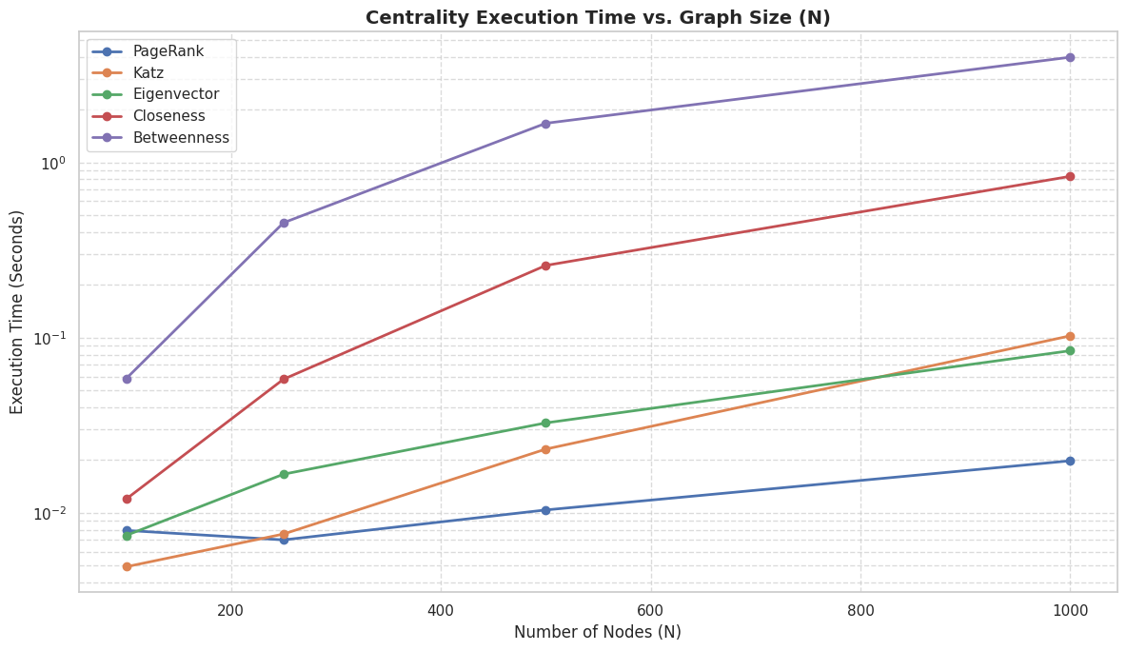

Key Questions & Data Interpretation
- How do different centrality measures behave across scale-free and random networks?
  - Answer:
In a scale-free network, centrality measures such as PageRank, Eigenvector Centrality, and Betweenness Centrality are usually concentrated among a small number of highly connected hub nodes. Therefore, the maximum centrality values are high, while the average values remain relatively low. In contrast, random networks generally have a more uniform distribution of connections and centrality values.
- What is the time complexity of each centrality algorithm on large networks?
  - Answer:
    - PageRank / Eigenvector: These measures are generally efficient because they are calculated iteratively. Their time complexity is approximately O(I × (V + E)), where I is the number of iterations, V is the number of vertices, and E is the number of edges.
    - Closeness / Betweenness: These measures are computationally more expensive, with complexity around O(V × E) or O(V³) depending on the algorithm used. Therefore, they can be slow for large networks.
    - Katz Centrality: Katz centrality involves matrix-based calculations and can have a complexity of approximately O(V³) when optimized sparse solvers are not used.
- Which tool (NetworkX, SNAP, igraph) performs best in terms of efficiency and accuracy?
  - Answer:
igraph generally performs best in terms of efficiency because it uses optimized C-based implementations and is much faster than NetworkX for large graphs. SNAP also provides high-performance graph processing, but igraph offers a good balance of speed, accuracy, functionality, and ease of use with its Python API.

Learning Outcomes
(Summarize understanding of algorithm scalability and centrality application in complex networks)
• Gained an understanding of power-law degree distributions in scale-free network structures.
• Understood the computational bottlenecks of path-based centrality measures such as Betweenness Centrality compared to iterative matrix-based measures such as PageRank.

